EXPERIMENT 3: AVERAGE SALE PRICE OF HOUSES WITH MORE THAN FOUR BEDROOMS

AIM
To calculate the average sale price of houses having more than four bedrooms using NumPy.

ALGORITHM
- Import the NumPy library.
- Create a NumPy array containing bedrooms, square footage, and sale price for each house.
- Select rows where the number of bedrooms is greater than four.
- Extract the sale prices from the selected rows.
- Calculate and display the average sale price. If no houses match, display a suitable message.

PROGRAM / CODE
import numpy as np
house_data = np.array([
[3, 1200, 200000],
[5, 1800, 350000],
[4, 1500, 280000],
[6, 2200, 450000],
[5, 2000, 400000]
])
selected_houses = house_data[house_data[:, 0] > 4]
if len(selected_houses) > 0:
average_price = np.mean(selected_houses[:, 2])
print("Average sale price:", average_price)
else:
print("No houses have more than four bedrooms.")

INPUT
House data (Bedrooms, Square Footage, Sale Price):
[[3, 1200, 200000],
[5, 1800, 350000],
[4, 1500, 280000],
[6, 2200, 450000],
[5, 2000, 400000]]

OUTPUT
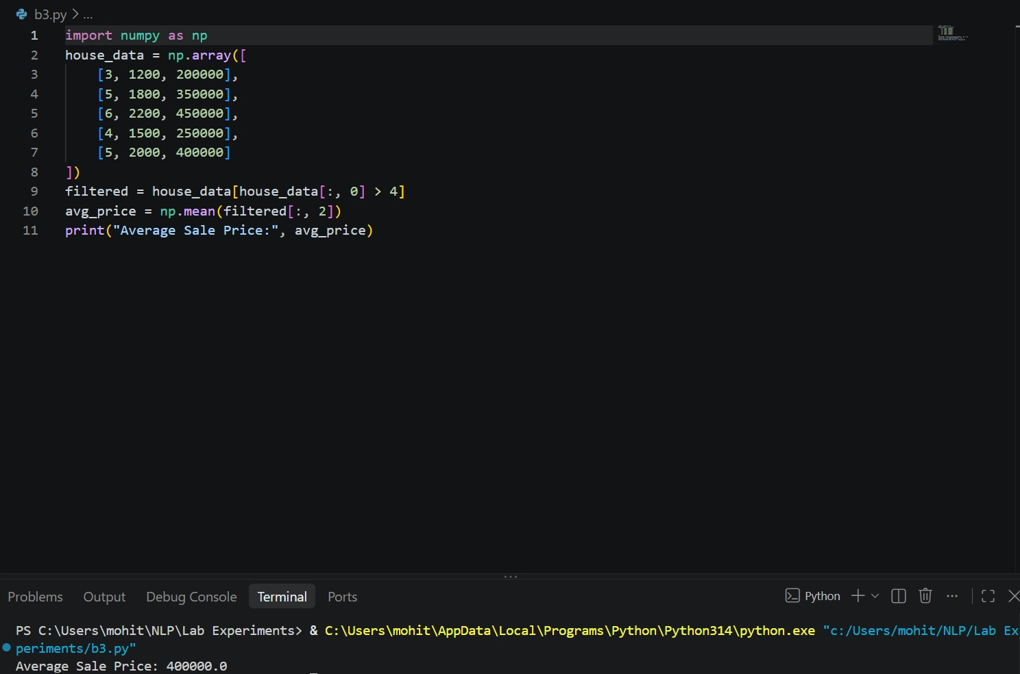
Average sale price: 400000.0

RESULT
The program selects houses with more than four bedrooms and calculates their average sale price as 400000.0.

